EC&C District Past Lieutenant Governor’s Committee
2023-2024 Chair DLGE Kermitt McGann kmcgann50@gmail.com
Sec./Treasurer PLG Rick Brooks rlbrooks.associates @gmail.com

Please join with us and give a warm welcome to our newest executive committee member, PLG Jim St.Jules (KC of Sault Ste. Marie, Division 2).

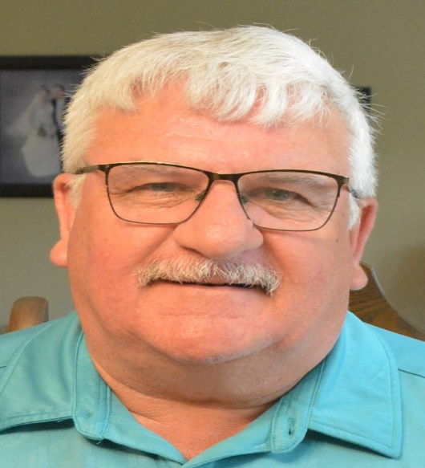
The members of the PLG Executive are pleased to be adding PLG Jim to our team as “Director of Education”. Jim is replacing our initial Director of Education, PLG William Downham, who stepped away for health reasons.
Jim brings with him over 26 years of Kiwanis experience. Jim is a four time Lt. Governor, their Kiwanis CLE Trainer, SLP Advisor, Chair of their PLG Committee and known in his club as someone who quietly gets things done.
Moved by PLG Rick Brooks and 2nd. by DLGE Sharon Williams – Approved unanimously
As PLG members, you will be hearing more from your executive committee, including Jim in our upcoming zoom membership meeting in March (details to follow).

The Four Pillars for a successful “Director of Education”
- Provide support and encouragement to our PLGs to consider serving as CLE Trainers, District Trustees or Governor, by sharing details on each of the roles on an ongoing basis. Provide guidelines to facilitate the implementation of mentorship programs.

- Liaise with the EC&C District Membership Growth Chair to ascertain divisions which need support; Club Coaches, Division PLG Committees and/or identifying a Division PLG contact person.

- Provide the leadership in organizing articles for the quarterly PLG Newsletter which represents the face of the PLG members and showcases our accomplishments from across the District, and always presenting ourselves in both English and French.

- Work cooperatively with the entire PLG Executive to establish a sub-committee focusing on the ongoing maintenance and accessibility of our website and other social media platforms to ensure they are available to all members.

We appreciate this is a major shift for some, but we believe if our membership gives their support and can accept the premise of Retention, Succession and Training, it will translate into stronger leaders and stronger clubs. Let’s work together to make this happen.

